Tourist attractions in the USA

Your task:
- Watch the pictures.
- Read the parts of the text and translate them.
- Try to match the pictures with their descriptions. Write down the name of the attraction on the line.
- There is one sentence that is odd in every part. Find and translate them. Write them out in the answer form.
- Compare the parts of the text with their translations. Find the mistakes and correct them.
- Put down your answers in the answer form.

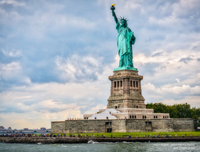 | 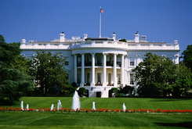 | 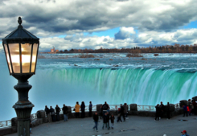 | 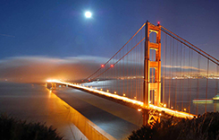
A | B | C | D
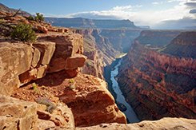 | 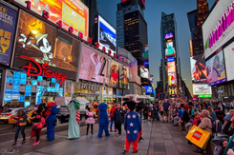 | 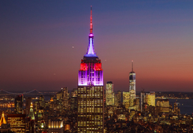 | 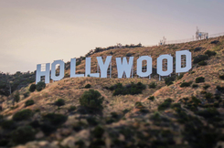
E | F | G | H

__________________________is a neighbourhood in Los Angeles. It is known as the home of the US film industry. A lot of film production studios are located here. For example, film studio "Paramount Pictures" is based in Hollywood. Many celebrities live in this neighbourhood. Many men, many minds. | __________________________is a square in the centre of Manhattan. It is not only the symbol of New York but the USA as well. This place is one of the most visited places of interest in the world. A lot of Broadway theatres are located in it. A lot of big companies also have their offices there. Stubborn as a mule. This place is full of bright neon advertisement which makes it a very recognizable place. | ________________________ are located on the border between Canada and the USA. It is a common name for three waterfalls – the American Falls, the Horseshoe Falls and the Bridal Veil Falls. They are not very high (53 metres) but very wide. Every year thousands of people visit this scenic place. Score twice before you cut once. There is the Rainbow Bridge over the river which connects both countries. It is open for pedestrians. | _______________________ is the official residence of the President of the USA. It is located in Washington. The building consists of 6 floors with different rooms including living space and halls for official receptions. The early bird catches the warm. George Washington was the only American president who didn't live in it. When he was the President, it did not exist. It was built in 1800. The famous Oval Office where the President of the USA works is located here.
1 | 2 | 3 | 4
__________________________ is located on Liberty Island in New York. In 1886 American people got it as a gift from the French. Since that time the statue has been the symbol of freedom and of the United States. An hour in the morning is worth two in the evening. The height of the Statue of Liberty is 93 metres (from ground level to torch). Visitors can admire the view of the harbour from its crown. | _________________________ is a world-famous bridge over the Golden Gate strait. It is one of the most recognisable places in the world and the symbol of the USA.  Its length is 2,7 km. Don’t trouble trouble, till trouble troubles you. The bridge was built in 1937 and connects San-Francisco and Marin County. | _________________________ is one of the deepest canyons in the world. Its depth is 1800 metres. It is located in Arizona on the territory of the national park. The length of the canyon is 446 km and its width varies from 6 to 29 km at the top and is less than 1 km at the bottom. New lords, new laws This is a very picturesque place. Every year thousands of tourists come here. | _________________________ is a famous skyscraper in New York. This building was the tallest building in the world for a long time. Out of sight, out of mind It has 103 floors. There are two observation decks in the building (on floors 86 and 102).  The height of the building is 443 metres. 73 lifts serve it. It is designed in a simple but elegant style. It is one of the symbols of American culture.
5 | 6 | 7 | 8

Answer form
Your name _____________________________________________ group _________
PICTURES | PARTS OF THE TEXT | THE NAME OF THE ATTRACTION

THE ODD SENTENCES | TRANSLATIONS

